
Koneru Lakshmaiah Education Foundation
(Deemed to be University estd. u/s. 3 of the UGC Act, 1956)
Off-Campus: Bachupally-Gandimaisamma Road, Bowrampet, Hyderabad, Telangana - 500 043. Phone No: 7815926816, www.klh.edu.in

STUDENT CASE STUDY EXECUTION REPORT
Department | FED
Sub'ect | DSA-2
Academic Year | 1-III Semester | 2025-26
Facult Name | Mohd.Razia
Student Name | U.Shiva Reddy
Roll Number | 2520090172
Branch | CSIT
Course Outcome | CO-5
Case Study Topic: Athlete Ranking Management using Heap Sort
Work Done Summary:
In the SportsAnalytics system, athlete rankings must be updated regularly based on their performance scores. Sorting thousands of athlete scores efficiently is important for generating leaderboards and ranking reports. Heap Sort is used to arrange athlete scores in ascending order while maintaining good performance for large datasets.
Implementation Details:
1) Store athlete performance scores in an array.
2) Construct a Max Heap from the scores.
3) Repeatedly extract the maximum element.
4) Place the extracted element at the end of the array.
5) Generate sorted rankings.
6 Analyze Heap Sort performance.
Result: Screenshots / Output

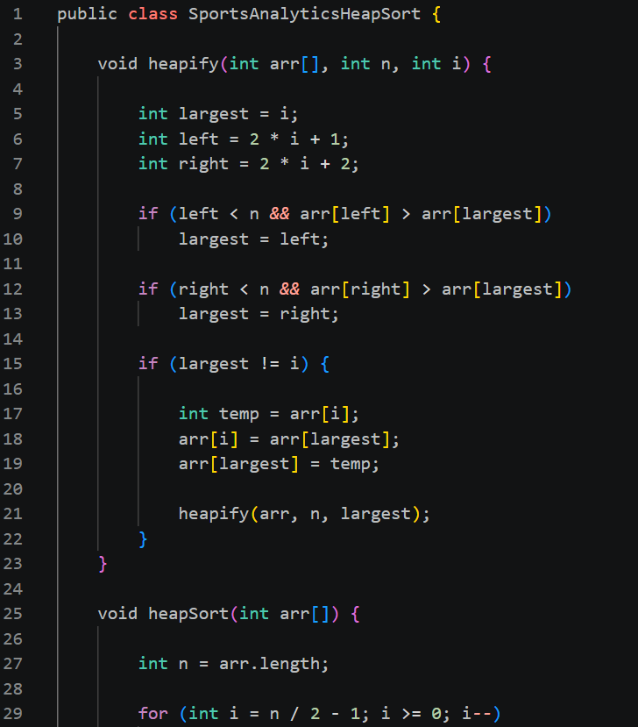
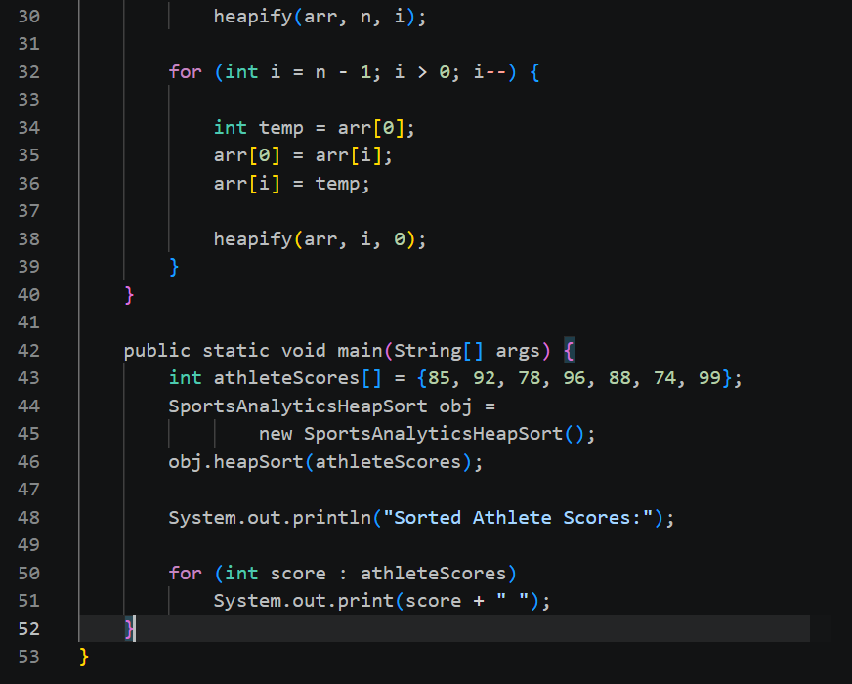

GitHub Link: https://github.com/Shiva77661/SportsAnalytics-Athlete-Performance-Tournament-Management-System/blob/main/sports%20analytics%20heap%20sort
Student Signature Faculty Signature

